Kayak Regatta!
Niantic River Appreciation Day
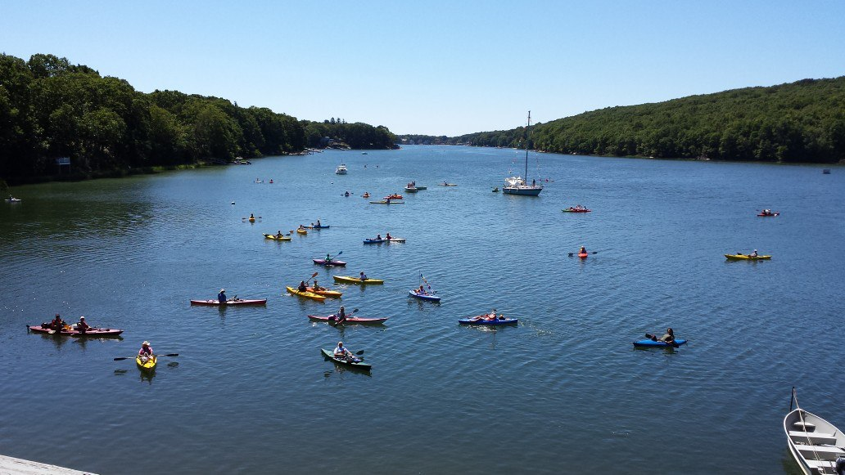
Saturday, August 20, 2016 from 10am-2pm
Free clam chowder from Flanders Fish!
Free hot dogs from The Dock!

Races!!

Music!!

Prizes!!
Kayak Parade!!

Music by Denise and Tony Band and Geoff Kaufman!! Kayak Parade: At 10 AM follow the Goshen Fireboat up the Niantic River in your Kayaks, Canoes, and SUP Boards to the festivities.
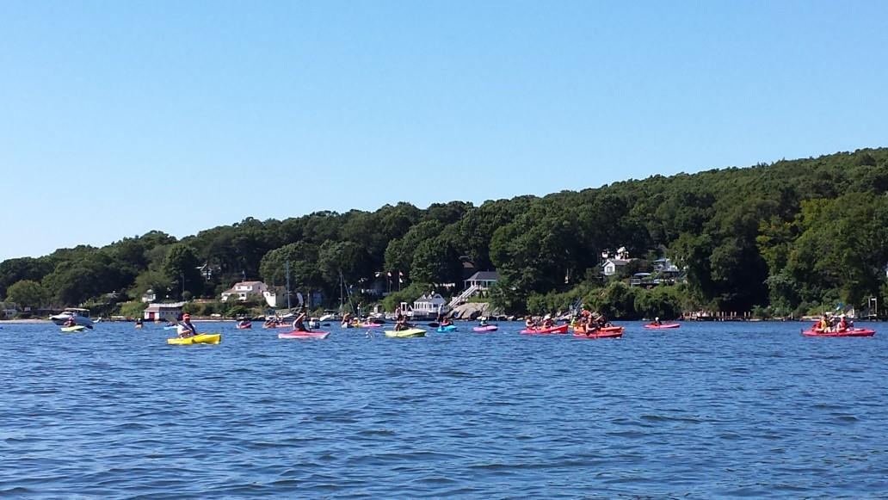
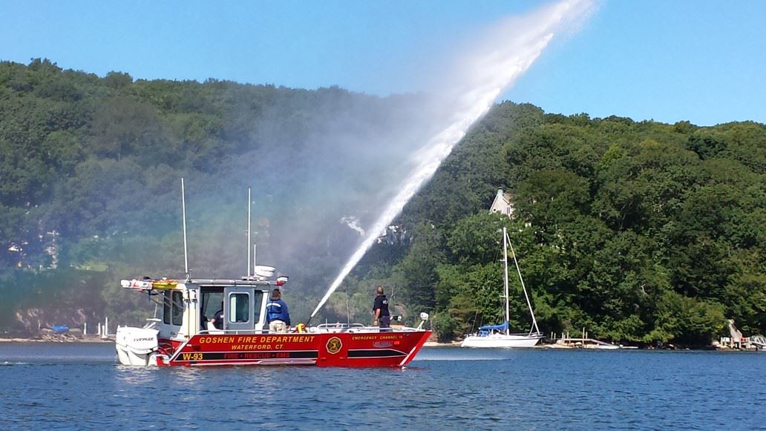
For more information call Deb Moshier-Dunn (860)444-9247

“Like” us on Facebook or see www.savetheriversavethehills.org RAIN DATE: Sunday, August 21, 2016

